Technical aspects of teleconsultation organization
Jacek Kosiński, Piotr Nawrocki
Department of Computer Science, AGH University of Science and Technology,
Mickiewicz Avenue 30, 30-059 Krakow, Poland
jgk@uci.agh.edu.pl, piter@agh.edu.pl
Introduction
The main objective of this article is to analyse technical conditionality for teleconsultation in public health. It presents some technical questions, both the most recent solutions and those applicable and popular from several years. This article depicts comparison of possible solutions based on ISDN[1] networks and leased line. It also presents classification of variants of different solutions depending on available hardware and software parameters such as delay, bandwidth. The focus will be on problems with network parameters, also methods and network solutions that make trouble-free transmission between consulting points possible will be presented.
Technical aspects of teleconsultation
Among many technical problems regarding network connection in teleconsultation the most important issues are connected with an access of all teleconference participants to network connection and determination of network parameters such as bandwidth, delay. Since these parameters change in time, e.g. in day cycle it is necessary to verify them. This article presents some possible variants of teleconsultations depending on network conditions. Two types of digital connections can be chosen presently: the ISDN and the Internet
The ISDN is a telecommunication service using digital phone line for direct connection between points. Constant parameters of network link, small delays, simple configuration and big availability are advantages of this solution. Since the high quality conference requires many channels it makes this solution too expensive.
Along with evolution of internet, wide range of services and capabilities of computer networks increased. Existing network protocols such as TCP/IP and UDP/IP [2] are based on packet transmission. This conception of transmission, among others, is suitable for multimedia of audio/video streams. The multimedia transmission requires specific conditions and parameters of the network. Possible lost of packets, lack of retransmission of packets, no authorized access are problems which the programmers of teleconsultation application must resolve. In comparison with files transfer, multimedia streaming do not need retransmission because in this specific transmission only current data are needed. The DSL, ADSL solutions are last more and more popular but this technology are not suitable for teleconference. These solutions have asymmetry transmission and only one direction has good bandwidth, in opposite direction transmission bandwidth is similar to dial-up technology (and it is not enough for multimedia transmission).
Software and hardware solutions
From among different operating systems, it is possible to use in teleconsultation workstation, the most suitable is MS Windows 2000. It seems probable that in future another operating system - Linux can be useful for multimedia teleconference. The very important thing for teleconsultation is choice technology of compression audio/video stream.
In software solutions, standard for A/V coding in IP and ISDN network is H.323 [3]. Features of this standard such as low bandwidth and popular application (for example NetMeeting in Microsoft Windows operating systems) which using this coding it cause that H.323 is widely popular in teleconference. The MPEG 1 [4] and MPEG2 [5] compression standards are also very popular. Because of this standards require high bandwidth (MPEG1 about 1 Mbps, MPEG2 about 6 – 8 Mbps) are useless in software scenarios.
The newest MPEG standard - MPEG4 [6] can be useful in teleconsultation based on only software solutions. Combination for optimal A/V stream many features from MPEG1/2 standards causes that this solution may be very useful and popular in the future. The format MPEG4 gives quality of video stream comparable to MPEG2 and bandwidth is lower than in MPEG1. Problem is that vendors have not negotiate between ourselves standard of MPEG4 that cause lack of finally software or hardware MPEG 4 solutions. It seems that this format will be popular in the future when all design and implementation works will be finished.
Apart software solutions, there are some hardware systems for teleconsultation. It is possible to distinguish available solutions on two groups. First group, it equipment which connect through ISDN or IP, ATM [7] networks. Second, it solutions based on MPEG standards where bandwidth must be high and only IP and ATM networks can be use in teleconsultation.
The “close” systems of videoconference are produced among others by group of firm Polyspan and Polycom (Fig. 1) and shows some example of this systems. In this solution often using coding standard is H.323 over ISDN and IP networks (with minimal bandwidth 128 kbps). The single system consists coding/decoding A/V modules, camcorder and microphone. This solution has some advantages such as easy service, different source signal A/V, automatic selection of transmission parameters and disadvantages for example that it can’t be develop. Public health excepts systems cost below commercial-off-the-shelf solutions. The “close” systems are designed for business teleconference and for this reason are too expensive. In the medicine quality of A/V teleconsultation stream should be good, and standard H.323 is not sufficient. Therefore only MPEG standards meet medicine teleconsultation conditions. Comparison quality of image in these standards is depicted in Fig. 2 and Fig. 3. Sometimes the “close” teleconferencing systems can be used in medicine with additional communicating equipment. High cost particularly are relatively to get quality of A/V stream is disadvantage for public health.

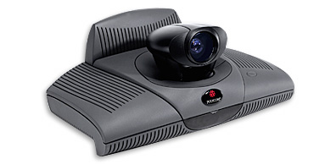
Fig. 1 Polycom ViewStation

The hardware solutions are very often based on MPEG standards. Currently MPEG1 and MPEG2 formats are used but in future with certitude will be also MPEG4. In the “open” solutions often encoders are PCI cards in computer, rare encoders are integrated. Usually integrated MPEG systems are professional solutions, taken advantage e.g. in television. It is proper to call attention from the point of view of high cost of system integrated on cheapest solutions, but often also more universal. Such solutions have encoders PCI cards with dedicated software. There are exist devices where encoding and decoding cards are integrated and products where cards are separate. This paper presents solution based on two separate Optibase [8] decoding and coding cards.
The main problem is choice of encoding standard. In the past the MPEG1 standard was often used. It quality of A/V stream was similar to analog TV transmission and bandwidth compressed stream was about 1380 kbps. The MPEG1 is suitable for live medical teleconsultations on condition that network has appropriate bandwidth. More complete standard of A/V coding is MPEG2. Quality of A/V stream is compare to quality digital satellite television and bandwidth is about 6500 kbps. Requirements for network are high and cost of this solution can be too high in medical practice. The newest standard MPEG4 is combination of MPEG1/2 standards and in the future can replace old solutions.

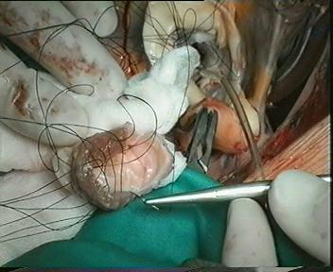
Fig. 2 Standard MPEG1

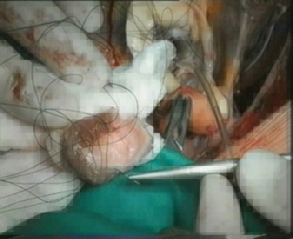
Fig. 3 Standard H.323
Network layer solutions
The modern computer networks enable to connect independant, until now, topologies for data, video and voice transmission into one infrastructure that uses IP technology. Connecting together so many applications having diverse requirements for parameters values in network layer forces to use Quality of Service mechanisms. These mechanisms enable to unify all available computer network’s usage with assurance of appopriate service level. QoS mechanisms are indispensable where traffic overloads potentialy may appear to assure that traffic sensitive to packet loses and delays (e.g. real-time audio and video) was better treated than computer data where those faults are better tolerated. Usage of QoS solutions is critical on point of contact of local networks with bandwith of hundreds MB and slow WAN links where aggregation to hundreds of kilobits of available bandwidth is done.
Characteristic of video trafic
Video traffic compared to e.g. single audio stream characterizes with large amount of sent packets and quite big changeability of packet rate with much higher average maximum transmission unit (MTU). Fig. 4 depicts typical frequencies of repeated packet sizes in standard teleconference transmission.

Fig. 4 Typical packet size breakdown of video conferencing traffic.

Additionaly, the packet stream, and being more precise its width expressed in number of packets per second or kbps is also very changeable. This changeability results from and is closely connected with the method of compression of movable image. In the stream a moment when the e.g. image frame with I compression is sent that usualy generates greater stream than the other frames (compression P,B) generating less amount of data (Fig. 5).

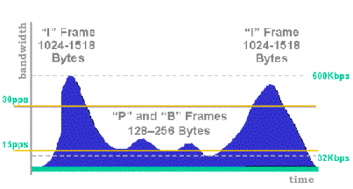
Fig. 5 Tipical bandwidth requirements
This characteristic should be considered while designing QoS arhitecture and consider apropriate bandwidth reservation for communication channels.

To provide the appropriate QoS guarantees to video traffic, network devices need to be able to identify such traffic.
The Differentiated Services (DiffServ) model of QoS uses DiffServ Code Point (DSCP) values to separate traffic into classes. DiffServ defines the following two sets of DSCP values:
- Expedited Forwarding (EF) - Provides a single DSCP value (101110) that gives marked packets the highest level of service from the network. Cisco implements EF service via LLQ. Generally, the high-priority queue is kept very small to control delay and to prevent starvation of lower priority traffic. The result may be dropped packets if the queue is full. EF is commonly considered most appropriate for Voice over IP (VoIP).
- Assured Forwarding (AF) - Provides four classes, each with three drop precedence levels
Traffic prioritizing
After marking traffic with proper DiffServ codes, appropriate streams can be assigned to queuees on network devices. Such assignment enable to prioritize e.g. traffic sensitive to delays or in case of traffic-jams enable to sent traffic sensitive to packet loses and drop the other (e.g. HTTP traffic).
Traffic Shaping
Using Frame Relay for WAN connectivity introduces another QoS requirement. Specifically, when a higher-speed central site feeds one or more lower-speed remote sites, the central site can overrun both the physical bandwidth and the CIR bandwidth of the remote site. To prevent too much traffic from being sent to a remote site, it is necessary to implement traffic shaping on the central-site router.
Scenarios of teleconference
In the telemedicine we can distinguish three potential scenarios of teleconsultation:

- High quality scenario (based on MPEG codecs)
- Conference based on H.323 codecs
- Voice (phone) teleconsultation

Every scenario requires special technical conditions connected with suitable network parameters (for example bandwidth, delay etc.). These scenarios including almost all potential application of medical teleconsultation depending on requirements and infrastructure (hardware, software and network). According to model of teleconsultation (Fig. 6), which seems that is the more suitable for hospitals, there are referential centers (for example experts in a renowned clinics) and local points of care (e.g. a city or rural hospitals). These scenarios are used for almost only point to point connection (according to assumption model). The costs of hardware and software in these solutions are difference, from most expensive in higher scenario (fast network, encoder MPEG1/2) to the cheapest voice teleconsultation. The very important technical aspect there is configuration workstation for telemedicine. The conception workstation [9] invents in the KI AGH is better then “close” solutions because the costs are lower and there are possibility to use in all scenarios.

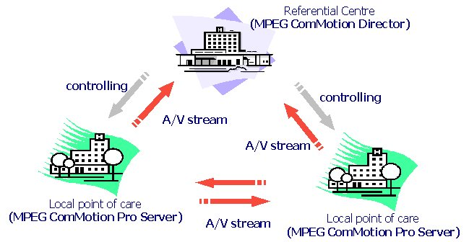
Fig. 6 Model of teleconsultation

The telemedicine workstation is a PC computer with additionally multimedia equipment. The operating system is using MS Windows 2000 but in future Linux can be possible. Minimal requirements for this telemedical workstation are: processor Pentium II 233 (or higher), 32 MB RAM, sound card, operating system MS Windows 2000 and encoder/decoder MPEG Optibase cards. The cost of workstation without MPEG cards is low and only Optibase equipment increases cost of this solutions.

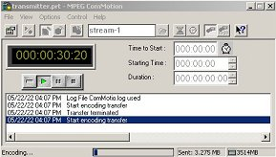
Fig. 7 MPEG ComMotion UDP
In the telemedicine workstation is used two Optibase cards: encoder MPEG1 - MovieMaker Xpress and decoder MPEG1/MPEG2 VideoPlex XPress. The encoding and decoding processes do not cause significant load of computer and the workstation can without problems run additional teleconsultation programs. Beside the Optibase hardware, there is used Optibase software for A/V streaming. The MPEG ComMotion UDP (Fig. 7) program is used for transmission multimedia stream for one sender to one or many receivers and configure of stream parameters such as quality image/sound, bandwidth etc. It is possible to use distribute Optibase transmission software: MPEG ComMoton Pro Server (Fig. 8) and MPEG ComMotion Director (Fig. 9) which allows remote control Optibase encoders by Web browser.

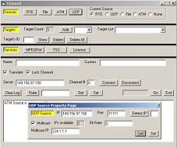
Fig. 8 MPEG ComMotion Pro Server
This solution help creating distribute environment consists of many servers with Optibase encoder card which are control by Web browser from one point. For receive MPEG stream is used decoder VideoPlex Xpress card with MPEG ComMotion Receiver software (Fig. 10). Beside telemedicine workstation are using some multimedia devices such as analog camcorder (as source of signal A/V), digital camera (for static photos) and monitor, TV set or multimedia projector (for presentation of A/V stream).

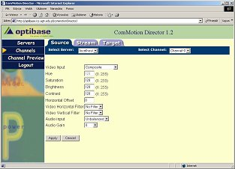
Fig. 9 MPEG ComMotion Director

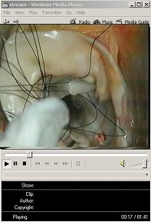
Fig. 10 MPEG ComMotion Receiver
As seen, the propose model of teleconsultation, scenarios and telemedicine workstation is cheap and very effective methods for medical telekonsultations.
Conclusion
The main limitations teleconference in medical care are network infrastructure and cost of equipment. The network should meet suitable parameters of link (bandwidth, delay, QoS etc). The specificity multimedia transmission requires continuous transfer of data and keeps suitable parameters of network. Without provision of proper transmission parameters on network level it might be impossible to organize a teleconference with the desired quality level. These applications are very sensitive to introduced delays, and particularly to its changeability. Therefore it is necessary to guarantee proper level of service and minimalize delays at the network side, if not then because of limited transmission buffers size the smoothness of decoding stream might be broken also the synchronization between audio and video might be lost.

Bibliography
- ISDN technology - http://hea-www.harvard.edu/~fine/ISDN/
- Richard Stevens - TCP/IP Illustrated, Addison-Wesley Publishing Company 1994
- H.323 specification - http://www.itu.int
- Description MPEG1 - http://www.chiariglione.org/mpeg/
- Description MPEG2 - http://www.chiariglione.org/mpeg/
- Description MPEG4 - http://www.chiariglione.org/mpeg/
- ATM technology - http://www.atmforum.com/
- Webpage Optibase - http://www.optibase.com/
- Dominik Radziszowski, Piotr Nawrocki - Systemy Wideotelekonferencyjne w Medycynie, Kraków 2002.

